Rob Just  
CS 241  
8/1/10

Final Project Users Guide

**Rot Cipher\Decipher Utility**  
  
**Screenshot:**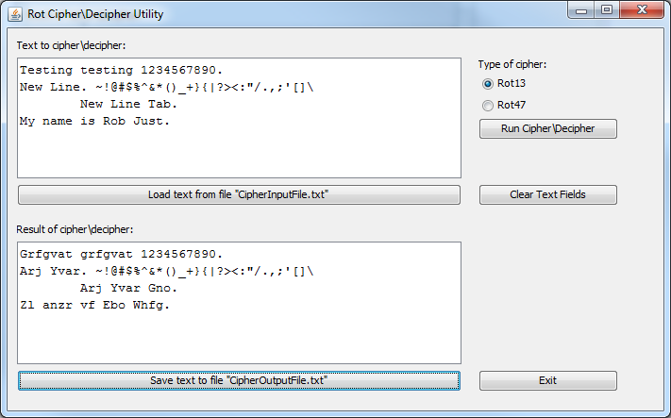  
**Description:**  
Many times I’ve wanted to send someone an email or post a message on a message board that I didn’t want someone to be able to read at a first glance. A common reason for this is to prevent spoiling TV shows or movies for people who haven’t seen them. A simple and fun way to do this is to use a rotation cipher to shift the letters of the text by a number of places to hide what the text really says. A popular cipher on internet message boards among other places is Rot13. Rot13 is a Caesar cipher that shifts each character in a string of text by 13 places in the alphabet. Another Caesar cipher is Rot47 which includes non-alphabet characters in the ASCII table and shifts the characters by 47 places from ASCII values 33 to 126. These ciphers have no security use as they can be reversed simply by running the text through the cipher again. They are simply used for entertainment and non-secure purposes.

This program will allow a user to type in, or load from a file, text to be ciphered\deciphered using either the Rot13 or Rot47 cipher. The results of the cipher\decipher can then be saved out to a text file.

1. The user will enter the text they wish to cipher\decipher into the “Text to cipher\decipher” text area box.
2. The user can also click the “Load text from file…” button to load text already saved in the file “CipherInputFile.txt” located in the program\project directory.
3. Then the user will select the cipher they wish to use by clicking the “Rot13” or “Rot47” radio buttons.
4. The user will then click the “Run Cipher\Decipher” button which will start the cipher\decipher process and output the results to the “Result of cipher\decipher” text area box.
5. Then, the user may save the results to the file “CipherOutputFile.txt” located in the program\project directory by clicking on the “Save text to file…” button.

**Input Example:**This is test input. 1234. My name is Rob.  
 **Output Example:**Rot13 = Guvf vf grfg vachg. 1234. Zl anzr vf Ebo.  
Rot47 = %9:D :D E6DE :?AFE] `abc] |J ?2>6 :D #@3]